**Tugas TD Time Series Analysis**

1. Identify proper ARIMA models for the following data sets (read across):

|  |  |  |
| --- | --- | --- |
| **Time** | **Soal A** | **Soal B** |
| 1 | -2.401 | 3.485 |
| 2 | -0.574 | 5.741 |
| 3 | 0.382 | 5.505 |
| 4 | -0.535 | 3.991 |
| 5 | -1.639 | 3.453 |
| 6 | -0.96 | 4.773 |
| 7 | -1.118 | 4.142 |
| 8 | -0.719 | 4.598 |
| 9 | -1.236 | 3.796 |
| 10 | 0.117 | 5.43 |
| 11 | -0.493 | 3.96 |
| 12 | -2.282 | 2.541 |
| 13 | -1.823 | 4.054 |
| 14 | 0.645 | 6.155 |
| 15 | -0.179 | 3.778 |
| 16 | 0.589 | 5.066 |
| 17 | 1.413 | 5.422 |
| 18 | 0.37 | 3.908 |
| 19 | 0.082 | 4.302 |
| 20 | -0.531 | 3.876 |
| 21 | -1.891 | 2.888 |
| 22 | -0.961 | 4.613 |
| 23 | -0.865 | 4.075 |
| 24 | -0.79 | 4.054 |
| 25 | -1.476 | 3.288 |
| 26 | -2.491 | 2.654 |
| 27 | -4.479 | 1.215 |
| 28 | -2.809 | 3.979 |
| 29 | -2.154 | 3.452 |
| 30 | -1.532 | 3.569 |
| 31 | -2.119 | 2.523 |
| 32 | -3.349 | 1.584 |
| 33 | -1.588 | 3.998 |
| 34 | 0.74 | 5.135 |
| 35 | 0.907 | 3.842 |
| 36 | 1.54 | 4.404 |
| 37 | 0.557 | 3.077 |
| 38 | 2.259 | 5.432 |
| 39 | 2.622 | 4.795 |
| 40 | 0.701 | 2.747 |
| 41 | 2.463 | 5.767 |
| 42 | 2.714 | 4.988 |
| 43 | 2.089 | 4.311 |
| 44 | 3.75 | 6.456 |
| 45 | 4.322 | 6.114 |
| 46 | 3.186 | 4.785 |
| 47 | 3.192 | 5.646 |
| 48 | 2.939 | 5.516 |
| 49 | 3.263 | 6.121 |
| 50 | 3.279 | 6.059 |
| 51 | 0.295 | 3.196 |
| 52 | 0.227 | 5.05 |
| 53 | 1.356 | 6.231 |
| 54 | 1.912 | 6.119 |
| 55 | 1.06 | 4.988 |
| 56 | 0.37 | 4.885 |
| 57 | -0.195 | 4.777 |
| 58 | 0.34 | 5.666 |
| 59 | 1.084 | 6.081 |
| 60 | 1.237 | 5.801 |
| 61 | 0.61 | 5.126 |
| 62 | 2.126 | 7.067 |
| 63 | 3.96 | 8.015 |
| 64 | 3.317 | 6.358 |
| 65 | 2.167 | 5.752 |
| 66 | 1.292 | 5.7 |
| 67 | 0.595 | 5.614 |
| 68 | 0.14 | 5.629 |
| 69 | -0.082 | 5.705 |
| 70 | 0.769 | 5.155 |
| 71 | 0.87 | 7.204 |
| 72 | 1.551 | 6.871 |
| 73 | 2.61 | 7.555 |
| 74 | 2.193 | 6.565 |
| 75 | 1.353 | 6.081 |
| 76 | -0.6 | 4.719 |
| 77 | -0.455 | 6.09 |
| 78 | 0.203 | 6.637 |
| 79 | 1.472 | 7.492 |
| 80 | 1.367 | 6.635 |
| 81 | 1.875 | 7.264 |
| 82 | 2.082 | 7.221 |
| 83 | 1.604 | 6.694 |
| 84 | 2.033 | 7.493 |
| 85 | 3.746 | 9.012 |
| 86 | 2.954 | 7.274 |
| 87 | 0.676 | 5.622 |
| 88 | 1.163 | 7.593 |
| 89 | 1.368 | 7.533 |
| 90 | 0.343 | 6.432 |
| 91 | -0.334 | 6.424 |
| 92 | 1.041 | 8.219 |
| 93 | 1.328 | 7.668 |
| 94 | 1.325 | 7.534 |
| 95 | 0.968 | 7.232 |
| 96 | 1.97 | 8.501 |
| 97 | 2.296 | 8.266 |
| 98 | 2.896 | 8.748 |
| 99 | 1.918 | 7.501 |
| 100 | 1.569 | 7.856 |

**Answer:**

4 steps to identify a tentative model:

* 1. Plot the time series data and choose proper transformations
  2. Compute and examine the sample ACF and the sample PACF of the original series to further confirm a necessary degree of differencing.
  3. Compute and examine the sample ACF and the sample PACF of the properly transformed and differenced series to identify the orders of *p* and *q*.
  4. Test the deterministic trend term θ0 when *d>0*.

**SOAL A**

1. Plot Data

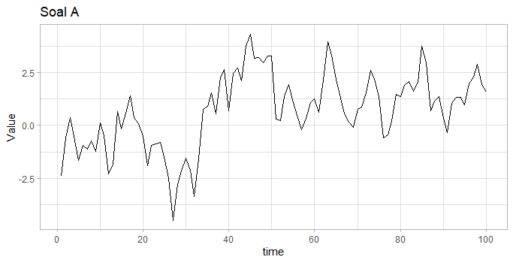

1. Differenced

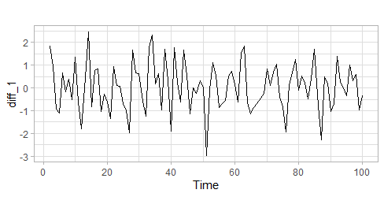

1. ACF and PACF

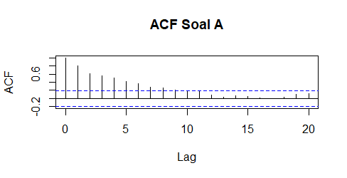

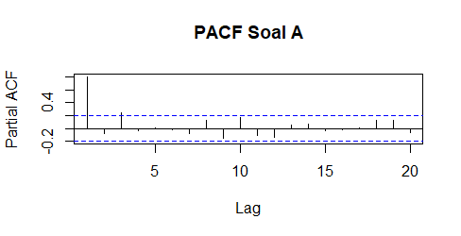

1. Forecast:

Series: myTS_1

ARIMA(0,1,0)

sigma^2 = 1.091: log likelihood = -144.77

AIC=291.54 AICc=291.58 BIC=294.13

Training set error measures:

ME RMSE MAE MPE MAPE MASE ACF1

Training set 0.03967599 1.039098 0.834264 16.02109 114.083 0.9900285 0.02155137

1. Residuals

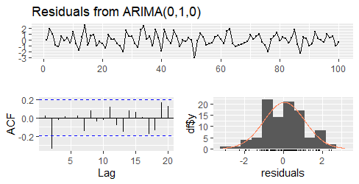

**SOAL B**

1. Plot

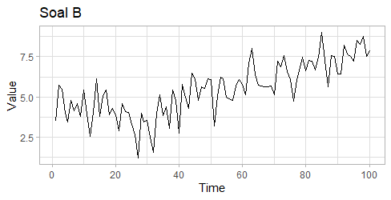

1. Differenced

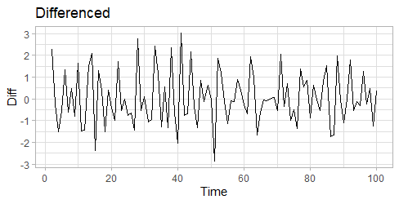

1. ACF and PACF

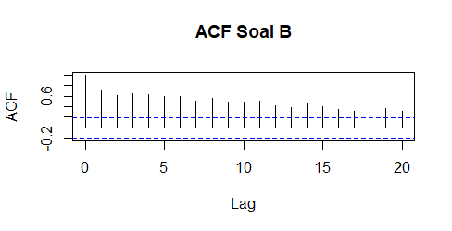

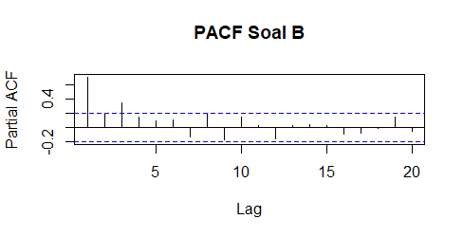

1. Forecast

ARIMA(2,1,1)

Coefficients:

ar1 ar2 ma1

0.0213 -0.3054 -0.6546

s.e. 0.1338 0.1138 0.1153

sigma^2 = 0.9864: log likelihood = -138.76

AIC=285.53 AICc=285.95 BIC=295.91

Training set error measures:

ME RMSE MAE MPE MAPE MASE ACF1

Training set 0.1414604 0.9731137 0.7751315 -2.498796 17.77102 0.7914154 -0.01412272

1. Residuals

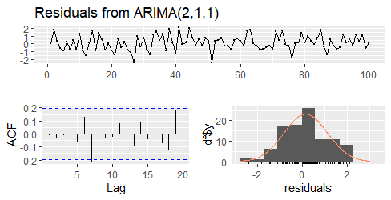

1. Consider the yearly data of lumber production (in billions of board feet) in the United States given as follows:

|  |  |  |  |  |  |  |  |  |  |  |  |
| --- | --- | --- | --- | --- | --- | --- | --- | --- | --- | --- | --- |
| **Year** | **Production** | | | | | | | | | | |
| 1921-1930 | 29 | 35.2 | 41 | 39.5 | 41 | 39.8 | 37.3 | 36.8 | 38.7 | 29.4 |
| 1931-1940 | 20 | 13.5 | 17.2 | 18.8 | 22.9 | 27.6 | 29 | 24.8 | 28.8 | 31.2 |
| 1941-1950 | 36.5 | 36.3 | 34.3 | 32.9 | 28.1 | 34.1 | 35.4 | 37 | 32.2 | 38 |
| 1951-1960 | 37.2 | 37.5 | 36.7 | 36.4 | 37.4 | 38.2 | 32.9 | 33.4 | 37.2 | 32.9 |
| 1961-1970 | 32 | 33.2 | 34.7 | 36.6 | 36.8 | 36.6 | 34.7 | 36.5 | 35.8 | 34.7 |
| 1071-1980 | 37 | 37.7 | 38.6 | 34.6 | 32.6 | 36.3 | 39.4 | 40.5 | 40.6 | 35.4 |
| 1981-1982 | 31.7 | 30 |  |  |  |  |  |  |  |  |

* + 1. Plot the data and perform the necessary analysis to construct an appropriate model for the series.

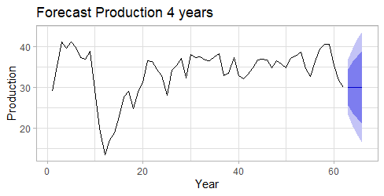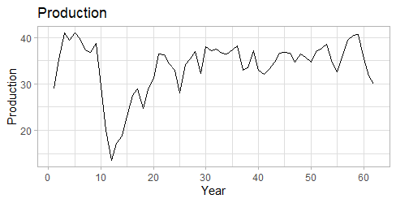

* + 1. Find and plot the forecasts for the next four years, and calculate 95% forecast limits.
    2. Update your forecasts when the 1983 observation became available and equaled 34.6.

1. Consider the following U.S. liquor sales (in millions of dollars):

|  |  |  |  |  |  |  |  |  |  |  |  |  |
| --- | --- | --- | --- | --- | --- | --- | --- | --- | --- | --- | --- | --- |
| **Year** | Jan. | Feb. | Mar. | Apr. | May | June | July | Aug. | Sept. | Oct. | Nov. | Dec. |
| 1970 | 580 | 514 | 555 | 563 | 627 | 596 | 632 | 639 | 577 | 611 | 639 | 875 |
| 1971 | 650 | 594 | 650 | 668 | 712 | 731 | 779 | 712 | 708 | 738 | 758 | 1073 |
| 1972 | 669 | 652 | 743 | 709 | 751 | 774 | 803 | 760 | 749 | 757 | 779 | 1066 |
| 1973 | 734 | 707 | 785 | 762 | 838 | 876 | 878 | 871 | 807 | 834 | 877 | 1236 |
| 1974 | 789 | 744 | 827 | 831 | 895 | 889 | 955 | 983 | 976 | 929 | 989 | 1294 |
| 1975 | 860 | 799 | 899 | 866 | 1016 | 978 | 1042 | 1026 | 944 | 1002 | 1009 | 1368 |
| 1976 | 908 | 849 | 916 | 958 | 1008 | 1033 | 1129 | 1019 | 984 | 1045 | 1049 | 1459 |
| 1977 | 910 | 927 | 981 | 1011 | 1041 | 1080 | 1138 | 1072 | 1033 | 1072 | 1111 | 1591 |
| 1978 | 950 | 932 | 1049 | 1021 | 1097 | 1151 | 1194 | 1174 | 1160 | 1135 | 1209 | 1692 |
| 1979 | 1071 | 1044 | 1158 | 1122 | 1209 | 1334 | 1360 | 1368 | 1297 | 1283 | 1375 | 1974 |
| 1980 | 1294 | 1258 | 1301 | 1297 | 1425 | 1378 | 1429 | 1452 | 1305 | 1377 | 1439 | 1958 |

* + 1. Build a seasonal ARIMA model for the series.

1. Plot

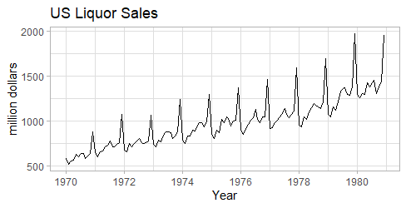

1. Model Seasonal ARIMA:

ARIMA(0,1,1)(1,1,0)[12]

Coefficients:

ma1 sar1

-0.6142 -0.3265

s.e. 0.0708 0.1007

sigma^2 = 1795: log likelihood = -614.59

AIC=1235.17 AICc=1235.38 BIC=1243.51

* + 1. Forecast the next 12 observations, and find their 95% forecast limits.

Point Forecast Lo 80 Hi 80 Lo 95 Hi 95

Jan 1981 1325.956 1271.655 1380.256 1242.910 1409.001

Feb 1981 1292.894 1234.693 1351.096 1203.883 1381.906

Mar 1981 1359.075 1297.218 1420.932 1264.473 1453.677

Apr 1981 1344.627 1279.319 1409.936 1244.747 1444.508

May 1981 1459.241 1390.655 1527.828 1354.347 1564.135

Jun 1981 1468.398 1396.683 1540.112 1358.719 1578.076

Jul 1981 1511.235 1436.523 1585.947 1396.973 1625.497

Aug 1981 1529.338 1451.744 1606.932 1410.669 1648.007

Sep 1981 1407.151 1326.779 1487.523 1284.233 1530.070

Oct 1981 1451.073 1368.016 1534.131 1324.048 1578.099

Nov 1981 1522.868 1437.209 1608.527 1391.864 1653.872

Dec 1981 2067.987 1979.803 2156.171 1933.122 2202.852

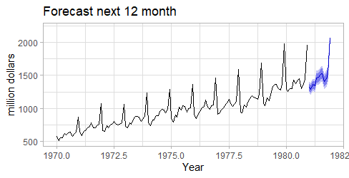

Point Forecast Lo 80 Hi 80 Lo 95 Hi 95

Jan 1981 1325.956 1271.655 1380.256 1242.910 1409.001

Feb 1981 1292.894 1234.693 1351.096 1203.883 1381.906

Mar 1981 1359.075 1297.218 1420.932 1264.473 1453.677

Apr 1981 1344.627 1279.319 1409.936 1244.747 1444.508

May 1981 1459.241 1390.655 1527.828 1354.347 1564.135

Jun 1981 1468.398 1396.683 1540.112 1358.719 1578.076

Jul 1981 1511.235 1436.523 1585.947 1396.973 1625.497

Aug 1981 1529.338 1451.744 1606.932 1410.669 1648.007

Sep 1981 1407.151 1326.779 1487.523 1284.233 1530.070

Oct 1981 1451.073 1368.016 1534.131 1324.048 1578.099

Nov 1981 1522.868 1437.209 1608.527 1391.864 1653.872

Dec 1981 2067.987 1979.803 2156.171 1933.122 2202.852

Jan 1982 1420.286 1315.000 1525.571 1259.265 1581.306

Feb 1982 1386.265 1275.295 1497.234 1216.551 1555.978

Mar 1982 1444.877 1328.501 1561.253 1266.895 1622.859

Apr 1982 1433.841 1312.298 1555.383 1247.957 1619.724

May 1982 1552.825 1426.327 1679.323 1359.363 1746.287

Jun 1982 1543.647 1412.380 1674.913 1342.892 1744.402

Jul 1982 1589.149 1453.281 1725.017 1381.357 1796.942

Aug 1982 1608.851 1468.532 1749.170 1394.252 1823.450

Sep 1982 1478.563 1333.931 1623.195 1257.367 1699.759

Oct 1982 1531.652 1382.831 1680.473 1304.050 1759.254

Nov 1982 1600.249 1447.354 1753.144 1366.417 1834.081

Dec 1982 2136.840 1979.978 2293.703 1896.939 2376.742

